**Non-Disclosure Agreement**

“To maintain the confidentiality of the confidential information shared by the Data Centre and Analytics Lab, Indian Institute of Management Bangalore (hereinafter called as “IIMB”) with its students for the AIESGCONF Datathon 2023 given to them, the following Undertaking Form is introduced which should be signed by the student.”

I, the undersigned, hereby undertake and abide by the following terms.

1. Confidential Information shall include all data, materials, products, technology, computer programs, specifications, manuals, business plans, software, marketing plans, financial information and other information disclosed or submitted, orally, in writing or by any other media to you directly or indirectly from IIMB or its Client.

2. I agree that the Confidential Information is to be considered confidential and proprietary to IIMB/its Client and I shall hold the same in confidence, shall not use the Confidential Information other than for the purposes of the AIESGCONF Datathon 2023 taken by me for IIMB or for its Client.

3. I undertake to use my best endeavours to:

(i) Hold IIMB’s/or its Client’s Confidential Information in confidence;

(ii) Not to divulge any such Confidential Information or any information derived there from to any third person or another writer or associate without prior consent in writing from IIMB.

(iii) I will limit any access to such Confidential Information to my associates, other writers, who must be absolutely necessary for the purpose of any assignment and that such other recipients are all subject to a binding obligation to comply with the terms of this undertaking in particular as regards keeping the confidentiality of such Confidential Information. The breach of this Undertaking by such other recipients shall be deemed in all respects to be breach by me.

(iv) Not to make use whatsoever at any time of such Confidential Information except for the purpose assigned by IIMB/its Client and relating to the matters and tasks, for which the Confidential Information was disclosed.

(v) I will not use the Confidential Information disclosed to me for any commercial purpose.

(vi) I will not duplicate the Confidential Information furnished to me in tangible form. And I will return all Confidential Information received in written or tangible form, including copies, or reproductions or other media containing Confidential Information within 10 days of the completion of the AIESGCONF Datathon 2023

or I will destroy the Confidential Information and provide a written certificate to IIMB regarding destruction of the same within 10 days thereafter as the case may be.

(vii) I agree not to disclose my participation, the existence or terms and conditions of this Undertaking, or the fact that discussions are being held with IIMB to any third party for the duration of this Undertaking or for 3 years thereafter.

(viii) I will not discuss future projects with IIMB’s Customer/Client, do any work for them or refer others to them for the above said period. I will not communicate with IIMB’s Customer/Client for any reasons whatsoever other than to complete the AIESGCONF Datathon 2023. All such communications to be made with the prior authorisation of IIMB only.

4. I acknowledge that this Undertaking shall remain in effect till the completion of the AIESGCONF Datathon 2023. Notwithstanding the foregoing, my duty to hold in confidence the Confidential Information that was disclosed during the term shall remain in effect indefinitely.

5. The Title to the Confidential Information will remain solely in IIMB/its Client. All the use of the Confidential Information by me shall be for the benefit of IIMB only.

6. All my obligations in this Undertaking shall not apply in respect of Confidential Information (or portions thereof) which

(i) was known by me before the receipt of the Confidential Information from IIMB and the same has to be proved;

(ii) becomes rightfully known to me from a third party source not known (after diligent inquiry) by me to be under an obligation to maintain confidentiality;

(iii) is or becomes publicly available through no fault of or failure to act by me in breach of this Undertaking; and

(iv) is or has been independently developed by me without violation of the terms of this Undertaking or reference or access to any Confidential Information.

7. This Undertaking is governed and construed in accordance with the Laws of the India.

8. I acknowledge that the Confidential Information to be disclosed hereunder is a unique and valuable character, and that the damages that would result from the unauthorised dissemination of the Confidential Information would be impossible to calculate. Therefore, I agree that IIMB shall be entitled to injunctive relief preventing the dissemination of any Confidential Information in violation of the terms hereof. Such injunctive relief shall be in addition to any other remedies available hereunder, whether at law or in equity.

**ACKNOWLEDGEMENT**

I have gone through carefully the terms of the above undertaking and understand the pros and cons of this Undertaking. I also understand that if I fail to comply with these terms; will be liable to suitable action as per rules and laws of India. I undertake that I will strictly follow the above terms. 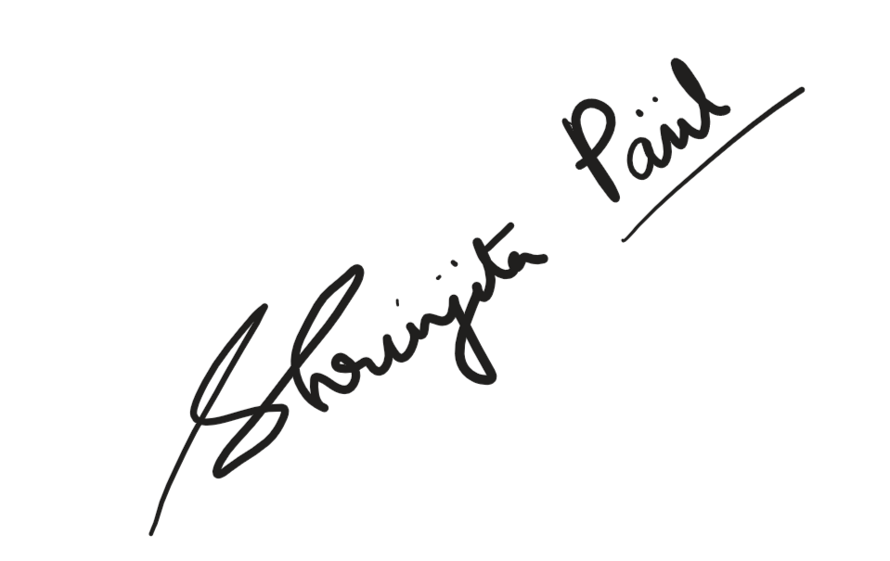

Signature of Student:

Name & Address: Shrinjita Paul ; 16 Hidaram Banerjee Lane Kolkata -700012

Contact No.: 7439947074

Registration/Roll No.: RA2211047010017

Course: Btech AI

Place: Chennai

Date:14/10/2023